./

GENESIS

Mini-project Summary Report



|  |  |  |  |  |  |
| --- | --- | --- | --- | --- | --- |
| **Ver. Rel. No.** | **Release Date** | **Prepared. By** | **Reviewed By** | **To be Approved** | **Remarks/Revision Details** |
| 1 |  | Madhura Subramanya Bhat  (99003589) |  |  |  |
| 2 |  | Harshitha D R  (99003575) |  |  |  |
| 3 |  | Mounika C H  (99003595) |  |  |  |

**Details**

Contents

Contents 3

Miniproject [Team] 4

Module/s 4

Introduction and specification 4

Components used 5

Design 6

Test Plan 6

description 7

Implementation summary 7

Git Link 9

Git Dashboard 9

Individual Contribution & Highlights 10

Summary 10

Challenges faced and how were they overcome 10

**RGB LED FADER**

**Modules:** SDLC, Linux and OS Programming, Embedded Linux.

**Introduction**

Beagle Bone Black is a low-cost, community-supported development platform for developers and hobbyists. Launched on April 23, 2013 at a price of $45. Among other differences, it increases RAM to 512 MB, the processor clock to 1 GHz, and it adds HDMI and 2 GB of eMMC flash memory. The Beagle Bone Black also ships with Linux kernel 3.8, upgraded from the original Beagle Bone's Linux kernel 3.2, allowing the Beagle Bone Black to take advantage of Direct Rendering Manager (DRM).

Beagle Bone Black Revision C (released in 2014) increased the size of the flash memory to 4 GB. This enables it to ship with Debian GNU/Linux installed. Previous revisions shipped with Ångström Linux.

**Specifications**

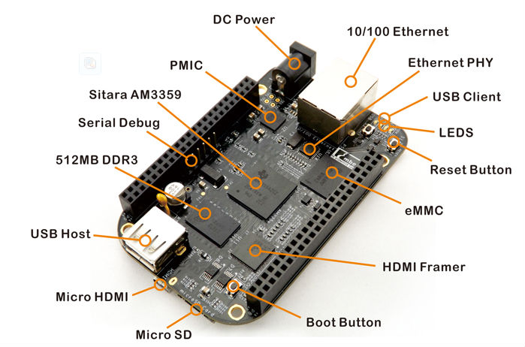

**Processor:** AM335x 1GHz ARM® Cortex-A8

* 512MB DDR3 RAM
* 4GB 8-bit eMMC on-board flash storage
* 3D graphics accelerator
* NEON floating-point accelerator
* 2x PRU 32-bit microcontrollers

**Software Compatibility**

* Debian
* Android
* Ubuntu
* Cloud9 IDE on Node.js w/ Bone Script library
* plus, much more

**Connectivity**

* USB client for power & communications
* USB host
* Ethernet
* HDMI
* 2x 46 pin headers

**Components Used**

1. Beagle Bone Black
2. RGB LED
3. Potentiometer
4. Jumper wires
5. Breadboard

**Design**

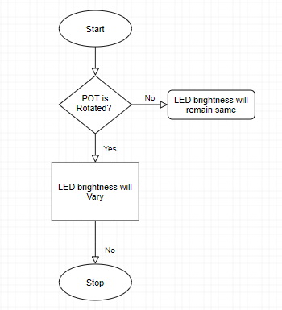

**Test Plan**

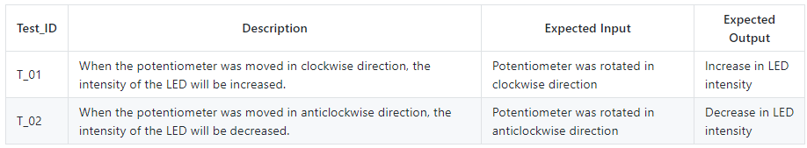

**Description**

A potentiometer (POT) is essentially a three-terminal resistor that acts as a voltage divider. When you adjust the value of the resistor, the voltage is increased or decreased in turn.

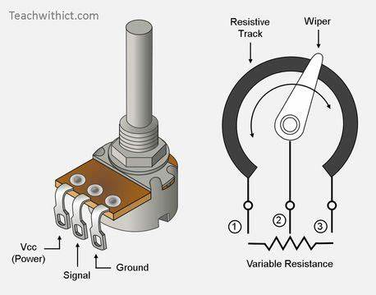

The RGB LED is connected to GPIO49 of Beagle Bone Black. Whenever we adjust the value of the resistor through potentiometer the brightness of led changes.

**Implementation Summary**

1. Connect the BBB to the system, power up with the USB cable.
2. Run sudo minicom in the linux terminal
3. Enter BBB
4. Set pin 49 of P9 header as input and output
5. Necessary connections are as below

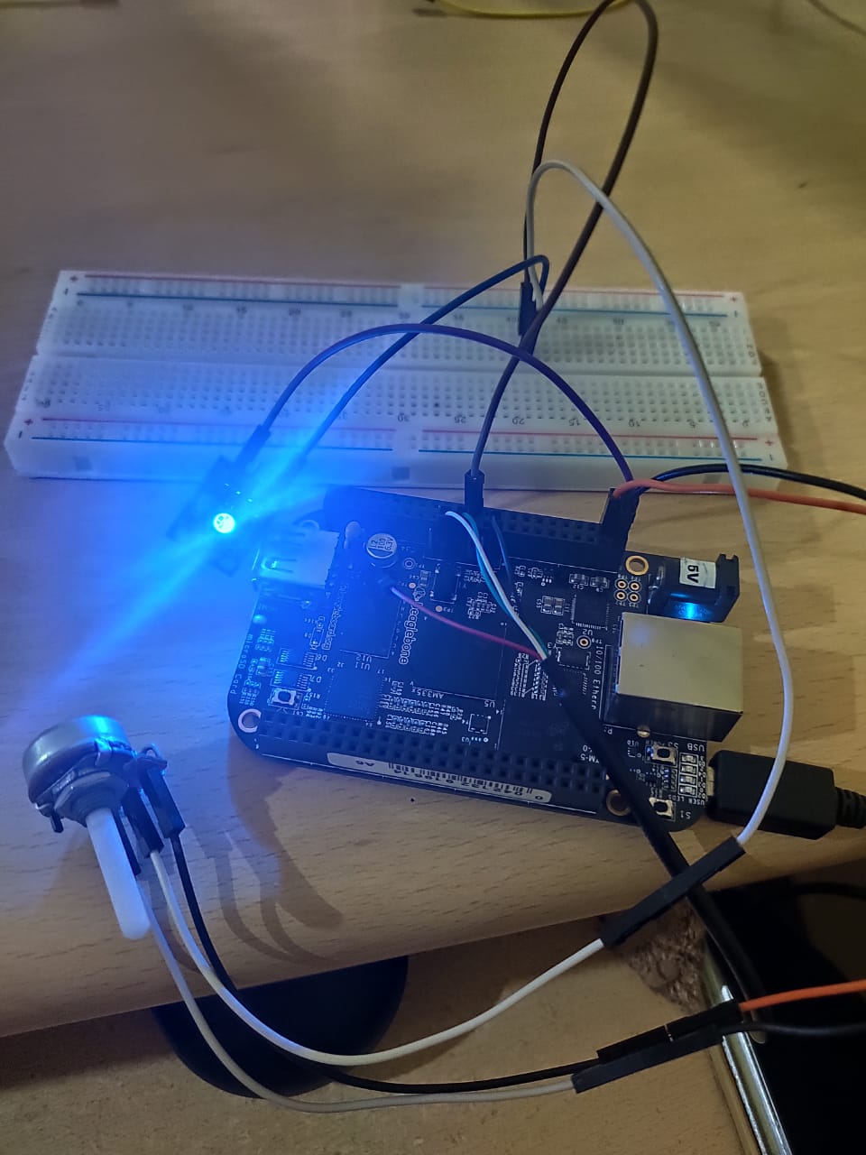

**GitHub Link:** [**https://github.com/99003575/Miniproject.git**](https://github.com/99003575/Miniproject.git)

**GitHub Dashboard:**

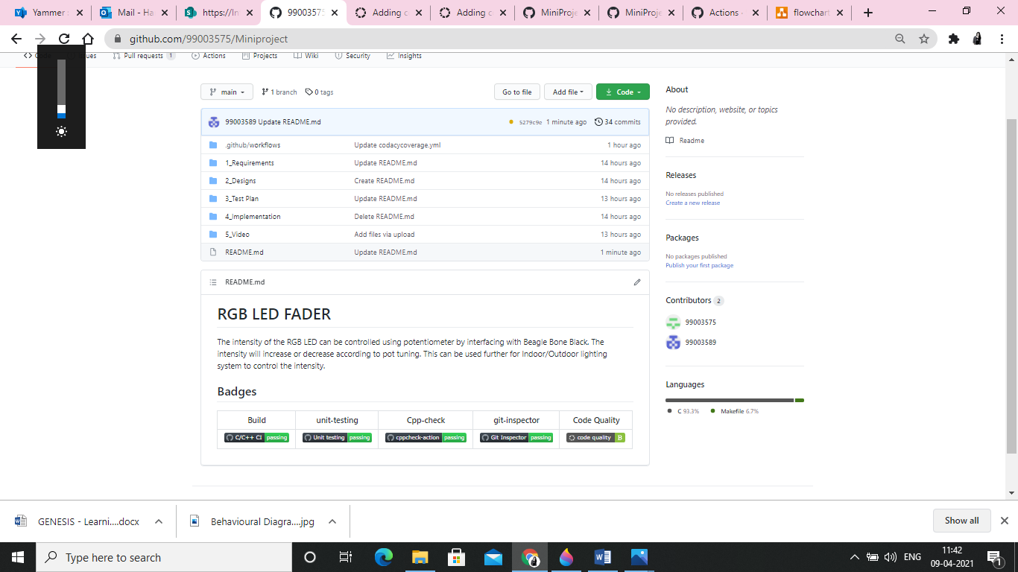

**Individual Contribution & Highlights**

Harshitha D R (99003575): Requirement gathering, Implementation, PPT, GitHub

Madhura Subramanya Bhat (99003589): Design, Implementation, Documentation, Video snippet

Mounika C H (99003595): Test Plan, Implementation, Documentation, GitHub

**Summary**

The intensity of the RGB LED can be controlled using potentiometer by interfacing with Beagle Bone Black. The intensity will increase or decrease according to pot tuning. This can be used further for Indoor/Outdoor lighting system to control the intensity.

**Challenges faced and how were they overcome**

Faced some problems in understanding the operation of POT and RGB. And faced some issues with beagle bone black board and is successfully resolved with the help of necessary resources.